Contents

Visual Studio 2017 Launch - Keynote Demos 1

Visual Studio 2017 Launch! 1

Visual Studio 2017 Keynote Demo Scripts 1

**Visual Studio 2017 Launch - Keynote Demos**

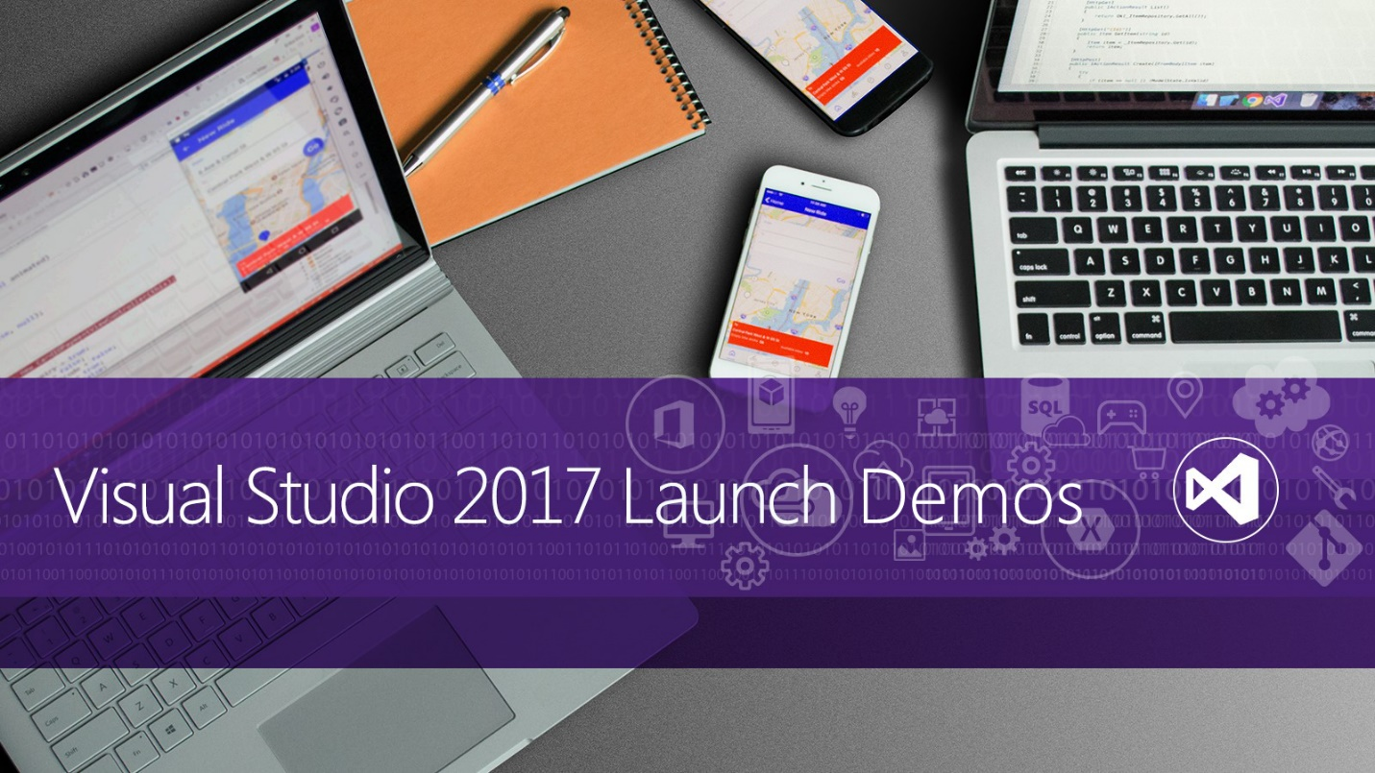

**Visual Studio 2017 Launch!**

We are happy to announce the release of Visual Studio 2017. This release brings a new lightweight and modular installation experience which can be tailored to your needs.

Use Visual Studio 2017 to develop apps for Android, iOS, Windows, web, and cloud. Code fast, debug and diagnose with ease, test often, and release with confidence. You can also extend and customize Visual Studio by building your own extensions. Use version control, be agile, and collaborate efficiently with this new release!

You can find the Visual Studio 2017 Launch Keynote demo [from here](https://channel9.msdn.com/Events/Visual-Studio/Visual-Studio-2017-Launch/100).

And you can download the Visual Studio 2017 Enterprise [from here](https://www.visualstudio.com/thank-you-downloading-visual-studio/?sku=Enterprise&rel=15).

**Visual Studio 2017 Keynote Demo Scripts**

Repo: <https://github.com/Microsoft/VisualStudio2017Launch_KeynoteDemos>

This repo has simplified versions of keynote demo scripts and access to multiple repos we used during the keynote. Individual feature demos are targeted towards developers. Each demo explains the feature and the value prop of the feature in detail.

**Note** - All the Visual Studio Enterprise features and Xamarin demos are based on the **BikeSharing360** application available at: [from here](http://aka.ms/bikesharing360).

| **Labs** | **Demo Script** | **Demo Video** | **Source Code** |
| --- | --- | --- | --- |
| Visual Studio 2017 Install and Performance | [Demo Script](https://github.com/Microsoft/VisualStudio2017Launch_KeynoteDemos/blob/master/Installation%20and%20better%20Performance) | [Demo Video](https://channel9.msdn.com/Events/Visual-Studio/Visual-Studio-2017-Launch/100#time=0h15m37s) | [Source Code](https://github.com/Microsoft/BikeSharing360_Productivity/tree/master/Lightweight) |
| Visual Studio 2017 Productivity | [Demo Script](https://github.com/Microsoft/VisualStudio2017Launch_KeynoteDemos/blob/master/Visual%20Studio%202017%20Productivity) | [Demo Video](https://channel9.msdn.com/Events/Visual-Studio/Visual-Studio-2017-Launch/100#time=0h20m32s) | [Source Code](https://github.com/Microsoft/BikeSharing360_Productivity/tree/master/code) |
| .NET Core tools in Visual Studio 2017 | [Demo Script](https://github.com/Microsoft/VisualStudio2017Launch_KeynoteDemos/blob/master/.NET%20Core%20tools%20in%20Visual%20Studio%202017) | [Demo Video](https://channel9.msdn.com/Events/Visual-Studio/Visual-Studio-2017-Launch/100#time=0h34m34s) | [Source Code](https://github.com/Microsoft/BikeSharing360_Websites/tree/master/VS2017-NetCoreTools-Demo) |
| Visual Studio Tools for Docker | [Demo Script](https://github.com/Microsoft/VisualStudio2017Launch_KeynoteDemos/blob/master/Microservices%20and%20Docker) | [Demo Video](https://channel9.msdn.com/Events/Visual-Studio/Visual-Studio-2017-Launch/100#time=0h42m22s) | [Single-container Source Code](https://github.com/Microsoft/BikeSharing360_SingleContainer/)  [Multi-container Source Code](https://github.com/Microsoft/BikeSharing360_MultiContainer) |
| Visual Studio and Xamarin | [Demo Script](https://github.com/Microsoft/VisualStudio2017Launch_KeynoteDemos/blob/master/XamarinCycle9) | [Demo Video](https://channel9.msdn.com/Events/Visual-Studio/Visual-Studio-2017-Launch/100#time=1h08m15s) | [Xamarin Azure Source Code](https://repos.opensource.microsoft.com/Microsoft/repos/VS2017-RTM-Xamarin-Cycle-9-Forms-Azure-Sample)  [BikeSharing360 Source Code](https://github.com/Microsoft/BikeSharing360_MobileApps) |
| Visual Studio Mobile Center | [Demo Script](https://github.com/Microsoft/VisualStudio2017Launch_KeynoteDemos/blob/master/Visual%20Studio%20Mobile%20Center) | [Demo Video](https://channel9.msdn.com/Events/Visual-Studio/Visual-Studio-2017-Launch/100#time=1h19m05s) | [BikeSharing360 Source Code](https://github.com/Microsoft/BikeSharing360_MobileApps) |
| Visual Studio Team Services and DevOps | [Demo Script](https://github.com/Microsoft/VisualStudio2017Launch_KeynoteDemos/blob/master/VSTS%20and%20DevOps) | [Demo Video](https://channel9.msdn.com/Events/Visual-Studio/Visual-Studio-2017-Launch/100#time=1h37m43s) | [Source Code](https://github.com/abelsquidhead/VSTSDemoKeynoteDemo1.git) |
| RedGate and Visual Studio 2017 | [Demo Script](https://github.com/Microsoft/VisualStudio2017Launch_KeynoteDemos/blob/master/Redgate%20and%20Visual%20Studio%202017) | [Demo Video](https://channel9.msdn.com/Events/Visual-Studio/Visual-Studio-2017-Launch/100#time=1h54m38s) | [Source Code](https://github.com/abelsquidhead/VS2017VSTSKeynoteDemo.git) |
|  |  |  |  |